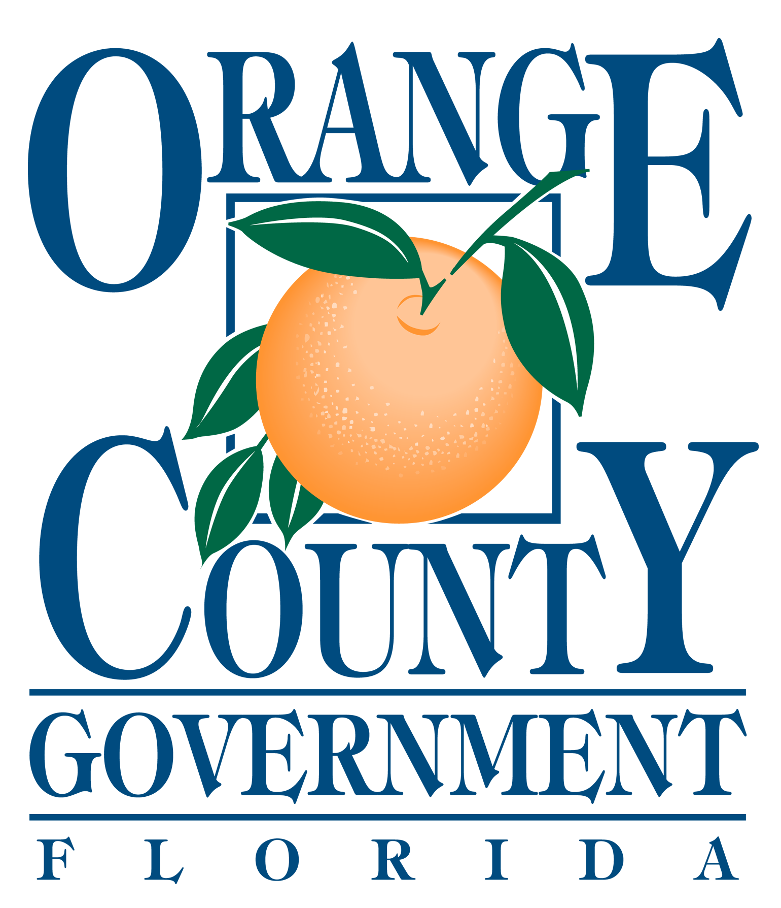

ORANGE COUNTY

NUISANCE ABATEMENT BOARD

PUBLIC HEARING

FEBRUARY 27, 2020

AGENDA

ATTENTION:

All Respondents appearing before the Orange County Nuisance Abatement Board, and/or Persons wishing
to speak, must complete an Appearance Request Registration Form and submit this form to the Clerk at the Information Desk, prior to your case being called.

Call to Order

Roll Call

Pledge of Allegiance

Approval of the Minutes from the October 24, 2019 Hearing

Opening Statement

Hearings:

Other Business Case(s):

1. NAB2019-N0004 7-ELEVEN, INC.
7-ELEVEN/MOBIL
2160 Americana Boulevard
Orlando, Florida
Non-Compliance

Public Comment

Comments by the Chairman

Election of Officers:

Date of Next Hearing: March 26, 2020

Adjournment:

Officials:
Orange County Mayor: Jerry L. Demings
Commission District 1: Betsy VanderLey
Commission District 2: Christine Moore
Commission District 3: Mayra Uribe
Commission District 4: Maribel Gomez Cordero
Commission District 5: Emily Bonilla
Commission District 6: Victoria P. Siplin
Orange County Administrator: Byron W. Brooks

