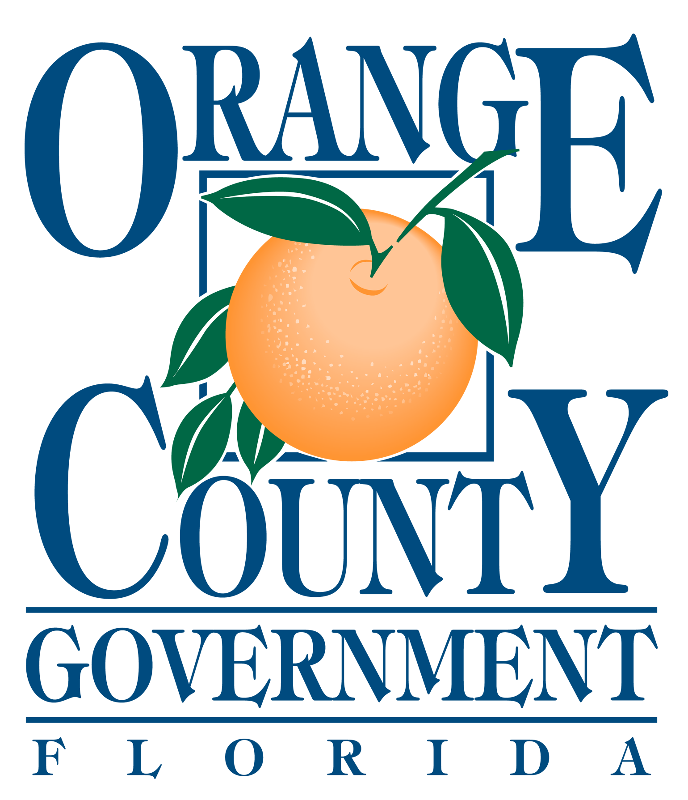

ORANGE COUNTY

NUISANCE ABATEMENT BOARD

PUBLIC HEARING

MAY 23, 2019

AGENDA

ATTENTION:

All Respondents appearing before the Orange County Nuisance Abatement Board, and/or Persons wishing
to speak, must complete an Appearance Request Registration Form and submit this form to the Clerk at the Information Desk, prior to your case being called.

Call to Order

Roll Call

Pledge of Allegiance

Public Comment

Discussion: Sheriff Mina

Approval of the Minutes from the March 28, 2019 Hearing

Opening Statement

Hearings:

New Case(s):

1. NAB2019-N003 MONA’S MINIMART, LLC
MARATHON
7501 University Boulevard
Orlando, Florida

This case is continued from the March 28, 2019 Nuisance Abatement Board Hearing

Other Business Case(s):

2. NAB2018-N002 HOLDEN FOODMART, LLC
CITGO/RIGHT WAY FOOD
7301 S. Orange Blossom Trail
Orlando, Florida

NON-COMPLIANCE

This case is continued from the March 28, 2019 Nuisance Abatement Board Hearing

3. NAB2016-N006 OBT CHEVRON, LLC
CHEVRON
4252 S. Orange Blossom Trail
Orlando, Florida

NON-COMPLIANCE

Foreclosure Consent Authorization Item(s):

4. NAB2015-N005 DIVA INVESTMENT PROPERTIES, INC.
D/B/A YOUNG’S MARKET/K&R FARM PRODUCE
2601 S. Orange Blossom Trail
Orlando, Florida

Comments by the Chairman:

Date of Next Hearing: June 27, 2019

Adjournment:

Officials:
Orange County Mayor: Jerry L. Demings
Commission District 1: Betsy VanderLey
Commission District 2: Christine Moore
Commission District 3: Mayra Uribe
Commission District 4: Maribel Gomez Cordero
Commission District 5: Emily Bonilla
Commission District 6: Victoria P. Siplin
Orange County Administrator: Byron W. Brooks

