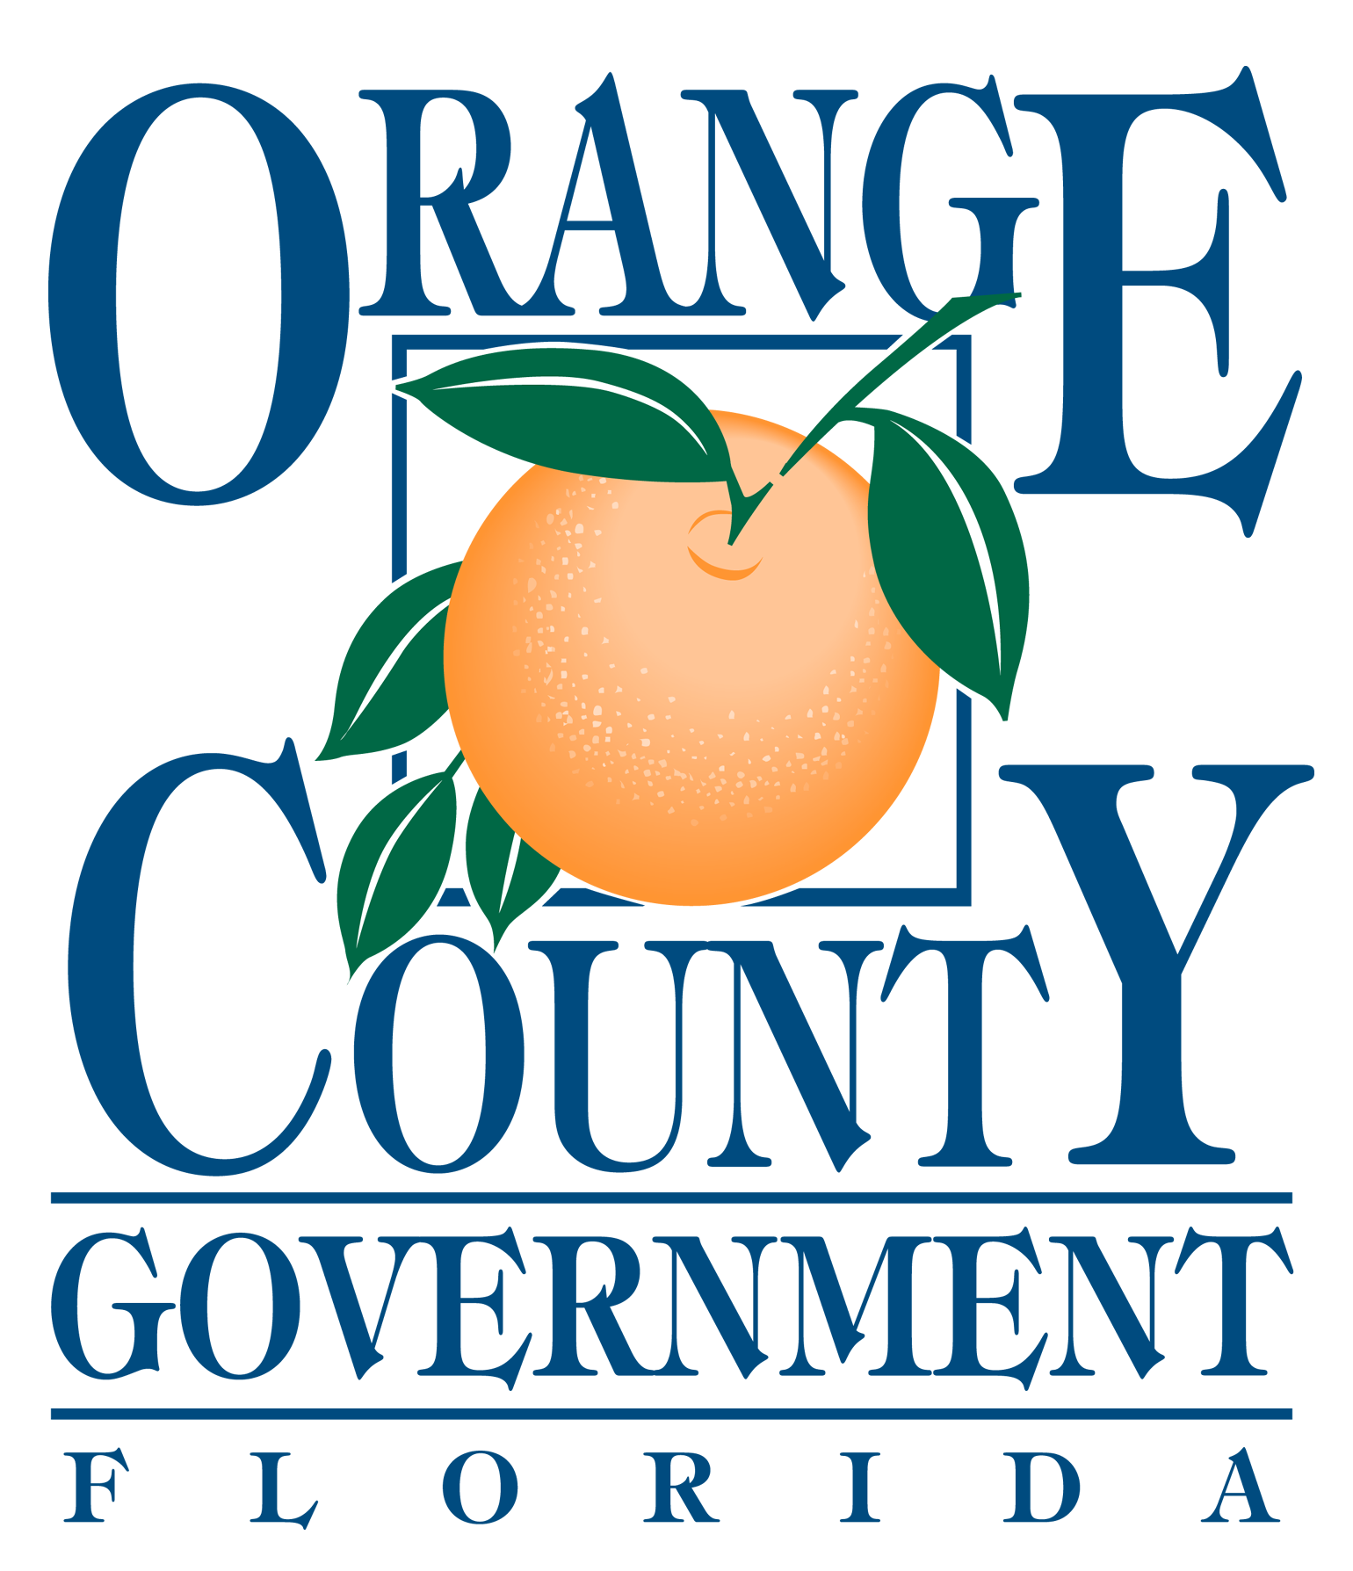

ORANGE COUNTY

NUISANCE ABATEMENT BOARD

PUBLIC HEARING

FEBRUARY 22, 2018

AGENDA

ATTENTION:

All Respondents appearing before the Orange County Nuisance Abatement Board, and/or Persons wishing
to speak, must complete an Appearance Request Registration Form and submit this form to the Clerk at the Information Desk, prior to your case being called.

Call to Order

Roll Call

Pledge of Allegiance

Approval of the Minutes from the December 14, 2017 Hearing

Opening Statement

Hearings:

Other Business:

1. NAB2017-N003 1405 43rd STREET LAND TRUST
c/o COMMON WEALTH TRUST SERVICES, LLC
1405 43rd Street
Orlando, Florida

NON-COMPLIANCE

Comments by the Chairman:

Election Of Officers:

Date of Next Hearing: March 22, 2018

Adjournment:

Officials:

Orange County Mayor: Teresa Jacobs
Commission District 1: Betsy VanderLey
Commission District 2: Bryan Nelson
Commission District 3: Pete Clarke
Commission District 4: Jennifer Thompson
Commission District 5: Emily Bonilla
Commission District 6: Victoria P. Siplin
Orange County Administrator: Ajit Lalchandani

